Lecture -1
Data is something every specific body contains of and their solution can be predictive or can be analyse using specific information from the users of the entity this information be generally refer as data.
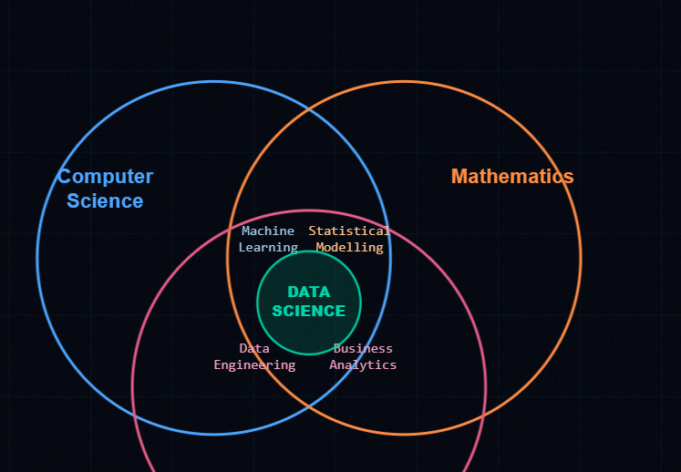
Compiler is one by one interpreter. it gives line by line error whether it is compile time error or runtime error.
Interpreter is a translator btw a developer and it’s his code. in this transition the specificity is testing a code execution the compile and the run time errors happen in specific one at the time.

Python:
  - platform independent
  - interpreter
  - high level lang
  - dynamic memory collection

-> Variable is objects key value.

Q. Wap to print the multiples of 5 in 3 different ways.
Q. Wap of which contains different functions the first function converts list which was given by the user into a matrix format of 3x3 , second function will convert the same list into a tuple and find the mean, median and mode and the third function will iterate over this function and find the gaps fill with null values respectively and gives a dictionary format mapped with first to the second function.
Q. Wap using function add two numbers
- if the sum if greater than the mid value of a list which is given by a user. print the set of the numbers before the mid value.
- if equals to mid value print the dictionary key with index of mid value and the value is mid itself.
- If sum is less than mid value then prints the tuple of numbers after the mid value.

Q. Why indexing is not possible in sets?

Lecture -2
Q. what is fstring?
Q. what is list comprehension in python?
Q. difference between break and return.
Ans. Break - Terminate the situation
Q. how can you store list inside dictionary and dictionary inside list?
Q. conversion of data structure list to tuple, tuple to set, set to dictionary.

How to give a prompt:
- Specify the subject you are looking for it.
- Specify the way of output.
- Specify the role of the user.
- Tell him your level.
- You have to make draft.
Q. I want to create a coffee machine of options:
Expresso
Americano
Cappuccino
Latte
Mocha
Cold coffee
based on the options using oops concept. clearly define the coffee machine with options using abstraction. The flow from expresso to American as a concept of inheritance followed from them to other options of the coffee machine make sure to specify overloading and overriding concept since the Parmeter of each recipe of coffees changes when each of them have different outcomes with same behavioural concept.
Q. Animal class parameter (eat, drink). Cat and dog using inheritance. Using decorators
TASK:
Take a data set from Kaggle specifically with shopping data like swiggy and Zomato, work on data cleaning, replace the data with averages if the data column is about amount and number of orders, replace the null cells of remaining with null cells.
Must know in oops:
- Relation between all oops concept between them.
- Overriding and overloading.

Lecture -3
NumPy is a library which is use to:
- It is use to manipulate or work only with numbers.
- It works with only array value structures.
- It is famous because it is vector (direction + magnitude).

Pandas:
- NumPy’s matrix is converted into table.
- Matrix+ metadata
- CSV
- Excels
- JSON
- HTML
Panda is layer of NumPy.
Project:
- Take a referral data of IPL matches of 2025. print the scores of data. convert the matches and the stadiums into an object format, make sure to print all the sequential data with processed output in layers. Create files of data of individual scores in separate pages locally.
Note: Understand how APIs work...…
- On the data of IPL try a specific model to allocate a stadium for the next match possible the RAG system should know, what is the match is to be happen in the sequence what would be the home ground and the players sequential data.
API:
The connection btw two application for the flow of data in
which where data are interlinked and use by

